**Implementation of AI-Powered Medical Diagnosis System**

A Project Report

submitted in partial fulfillment of the requirements

of

AICTE Internship on AI: Transformative Learning

with

TechSaksham – A joint CSR initiative of Microsoft & SAP

by

**Kassa Sanath kumar, kassasanathkumar@gmail.com**

Under the Guidance of

**Saomya**

**ACKNOWLEDGEMENT**

We would like to take this opportunity to express our deep sense of gratitude to all individuals who helped us directly or indirectly during this thesis work.

Firstly, we would like to thank my supervisor,Saomya for being a great mentor and the best adviser I could ever have. His advice, encouragement and the critics are a source of innovative ideas, inspiration and causes behind the successful completion of this project. The confidence shown in me by him was the biggest source of inspiration for me. It has been a privilege working with him for the last one year. He always helped me during my project and many other aspects related to the program. His talks and lessons not only help in project work and other activities of the program but also make me a good and responsible professional.

#### **ABSTRACT**

Healthcare diagnostics play a crucial role in early disease detection and treatment planning. However, access to timely and accurate medical diagnosis remains a challenge, particularly in resource-limited settings. This project presents an **AI-powered Medical Diagnosis System** designed to assist in the early detection of diseases such as **Diabetes, Heart Disease, Parkinson’s, Lung Cancer, and Hypothyroidism** using machine learning models.

The **objective** of this project is to develop a user-friendly web application that allows users to input medical parameters and receive predictive insights about potential health conditions. This system aims to complement traditional medical diagnostics by providing quick, data-driven assessments based on trained machine learning models.

The **methodology** involves data preprocessing, feature selection, and training multiple machine learning models on medical datasets. The models were trained using **Scikit-learn** and implemented using **Streamlit** to create an interactive web application. Each disease model was optimized using appropriate classification techniques, including Decision Trees, Random Forest, and Support Vector Machines. The trained models were serialized using **Pickle** for deployment.

The **key results** indicate that the models achieved high accuracy in predicting disease likelihood based on patient input data. The web application enables users to conveniently access preliminary diagnostic insights, making healthcare assistance more accessible.

In **conclusion**, this project demonstrates the potential of AI in healthcare by offering a scalable, efficient, and cost-effective solution for preliminary medical diagnosis. While it is not a replacement for professional medical consultation, it serves as a valuable decision-support tool for early screening and awareness. Future enhancements could include integrating real-time patient data, improving model accuracy with larger datasets, and expanding disease coverage.

**TABLE OF CONTENT**

**Abstract I**

**Chapter 1.**  **Introduction 1**

1.1 Problem Statement 1

1.2 Motivation 1

1.3 Objectives 2

1.4. Scope of the Project 2

**Chapter 2.**  **Literature Survey 3**

**Chapter 3.**  **Proposed Methodology 6**

**Chapter 4.**  **Implementation and Results 8**

**Chapter 5. Discussion and Conclusion 9**

**References** 11

**LIST OF FIGURES**

|  |  |  |
| --- | --- | --- |
| **Figure No.** | **Figure Caption** | **Page No.** |
|  | Open in web browser | **8** |
|  | Code in code editor | **8** |

**CHAPTER 1**

**Introduction**

**1.1 Problem Statement**

Timely and accurate medical diagnosis is essential for effective treatment and disease management. However, healthcare accessibility remains a challenge, particularly in remote areas with limited medical infrastructure. Additionally, manual diagnosis is prone to human error and can be time-consuming, leading to delayed treatment. This project addresses the need for an AI-powered Medical Diagnosis System that assists in early disease detection using machine learning models. By leveraging artificial intelligence, the system provides automated, data-driven insights to support medical professionals and individuals in assessing potential health conditions.

**1.2 Motivation**

This project was chosen due to the increasing global burden of chronic and life-threatening diseases such as Diabetes, Heart Disease, Parkinson’s, Lung Cancer, and Hypothyroidism. Early detection of these diseases significantly improves treatment outcomes and reduces mortality rates. However, many people lack access to regular health checkups due to financial constraints, geographical limitations, or lack of awareness. By developing a user-friendly AI-driven system, this project aims to provide an affordable and accessible diagnostic tool that can assist individuals in evaluating their health risks.

**Potential Applications and Impact:**

* Medical Assistance: Supports doctors by providing AI-driven preliminary diagnosis.
* Remote Healthcare: Helps individuals in underserved areas access basic diagnostic services.
* Early Detection: Identifies potential health risks before symptoms become severe.
* Awareness and Prevention: Encourages individuals to seek medical attention sooner.

**1.3 Objectives**

**The primary objectives of this project are:**

* To develop a machine learning-based diagnostic system for predicting the likelihood of specific diseases.
* To design a user-friendly web application that enables individuals to input health parameters and receive instant predictions.
* To train reliable machine learning models using real-world medical datasets.
* To enhance healthcare accessibility by providing a cost-effective diagnostic tool.
* To encourage early disease detection and preventive care through AI-powered predictions**.**

**1.4 Scope of the Project**

This project focuses on predicting five major diseases—Diabetes, Heart Disease, Parkinson’s, Lung Cancer, and Hypothyroidism—using machine learning algorithms. It includes:

* Data Collection & Preprocessing: Using publicly available medical datasets.
* Model Development: Training and optimizing machine learning models.
* Web Application Deployment: Implementing the system using Streamlit for user interaction.

**Limitations:**

* The system provides predictive insights but does not replace professional medical diagnosis.
* The accuracy of predictions depends on data quality and model performance.
* The models may require continuous updates and validation with real-world clinical data.
* The current scope is limited to five diseases, and expanding coverage would require additional datasets and retraining.

**CHAPTER 2**

**Literature Survey**

**2.1 Review of Relevant Literature**

The integration of machine learning in medical diagnostics has been widely explored in recent years. Various studies highlight the effectiveness of AI-driven models in disease prediction and classification.

* Diabetes Prediction:  
  Studies such as [Ming et al., 2020] have demonstrated the use of Logistic Regression, Random Forest, and Support Vector Machines (SVM) in predicting diabetes based on patient attributes such as glucose levels, BMI, and age.
* Heart Disease Prediction:  
  Research by Dey et al. (2019) implemented Artificial Neural Networks (ANNs) to detect heart disease, showing improved accuracy over traditional methods.
* Parkinson’s Disease Detection:  
  Voice-based and biometric feature analysis have been explored using Support Vector Machines and Deep Learning Models to classify Parkinson’s patients.
* Lung Cancer Prediction:  
  Studies have used Convolutional Neural Networks (CNNs) to detect lung cancer from radiographic images, improving detection rates compared to manual screenings.
* Hypothyroidism Diagnosis:  
  Machine learning techniques like Decision Trees and Naïve Bayes classifiers have been applied to diagnose thyroid disorders using biochemical test results.

**2.2 Existing Models, Techniques, and Methodologies**

The existing approaches to medical diagnosis primarily rely on:

* Supervised Machine Learning Models
  + Logistic Regression, Decision Trees, Random Forest, SVM, and Neural Networks.
* Deep Learning-Based Image Processing
  + CNNs for medical imaging analysis in cancer and tumor detection.
* Electronic Health Records (EHR) Analysis
  + Data mining techniques applied to patient records for disease prediction.
* Wearable Technology and IoT-based Diagnosis
  + Real-time health monitoring using IoT sensors for heart rate, blood pressure, and glucose levels.

**2.3 Gaps and Limitations in Existing Solutions**

Despite advancements, several challenges remain in AI-driven medical diagnostics:

* Data Availability & Quality: Many models rely on publicly available datasets, which may not be comprehensive or diverse enough.
* Model Interpretability: Some deep learning models function as "black boxes," making it difficult for doctors to interpret predictions.
* Limited Disease Coverage: Many studies focus on single-disease prediction rather than a multi-disease diagnostic system.
* Generalization Issues: Machine learning models trained on specific datasets may not generalize well across different populations.
* User Accessibility: Existing AI-driven solutions often require specialized knowledge, limiting their usability for the general public.

How Our Project Addresses These Gaps:

* Multi-Disease Prediction: Unlike single-disease models, our system integrates multiple models for detecting Diabetes, Heart Disease, Parkinson’s, Lung Cancer, and Hypothyroidism in one platform.
* User-Friendly Web Application: Using Streamlit, we provide an easy-to-use interface, making AI-powered diagnostics accessible to non-technical users.
* Optimized Machine Learning Models: We use a combination of Random Forest, SVM, and Decision Trees, ensuring high accuracy and interpretability.
* Scalability: Our modular design allows for future expansion to include more diseases.
* Transparent & Explainable AI: We focus on interpretable models, providing users with understandable insights into their health predictions.

**CHAPTER 3**

**Proposed Methodology**

**3.1 System Design**

The AI-powered Medical Diagnosis System follows a structured pipeline for disease prediction, involving data collection, preprocessing, model training, and deployment via a web application. The architecture consists of the following key components:

**System Design Diagram:**

***(You can add a block diagram representing this workflow in your*** *report.)*

1. User Input (Web Interface):
   * Users enter relevant medical details (e.g., glucose level, heart rate, symptoms).
2. Data Preprocessing:
   * The system normalizes and processes input data to match the trained models.
3. Machine Learning Models:
   * Different pre-trained models predict disease likelihood based on input parameters.
4. Prediction Output:
   * The system displays disease risk probability and suggestions for further consultation.
5. User Feedback & Model Improvement:
   * User interaction data can be used for future model improvements.

**3.2 Requirement Specification**

**3.2.1 Hardware Requirements**

* Processor: Intel i5 or above (or equivalent AMD)
* RAM: Minimum 8GB (16GB recommended for large dataset handling)
* Storage: At least 20GB free space
* GPU (Optional): Required if deep learning is integrated for image-based diagnosis

**3.2.2 Software Requirements**

* Programming Language: Python 3.x
* Frameworks & Libraries:
  + Machine Learning: Scikit-learn, Pandas, NumPy
  + Web Development: Streamlit (for user interface)
  + Model Deployment: Pickle (for saving trained models)
* Operating System: Windows/Linux/MacOS
* Version Control: GitHub (for collaboration and deployment)
* IDE: Jupyter Notebook, VS Code, or PyCharm

**CHAPTER 4**

**Implementation and Result**

* 1. **Snap Shots of Result:**

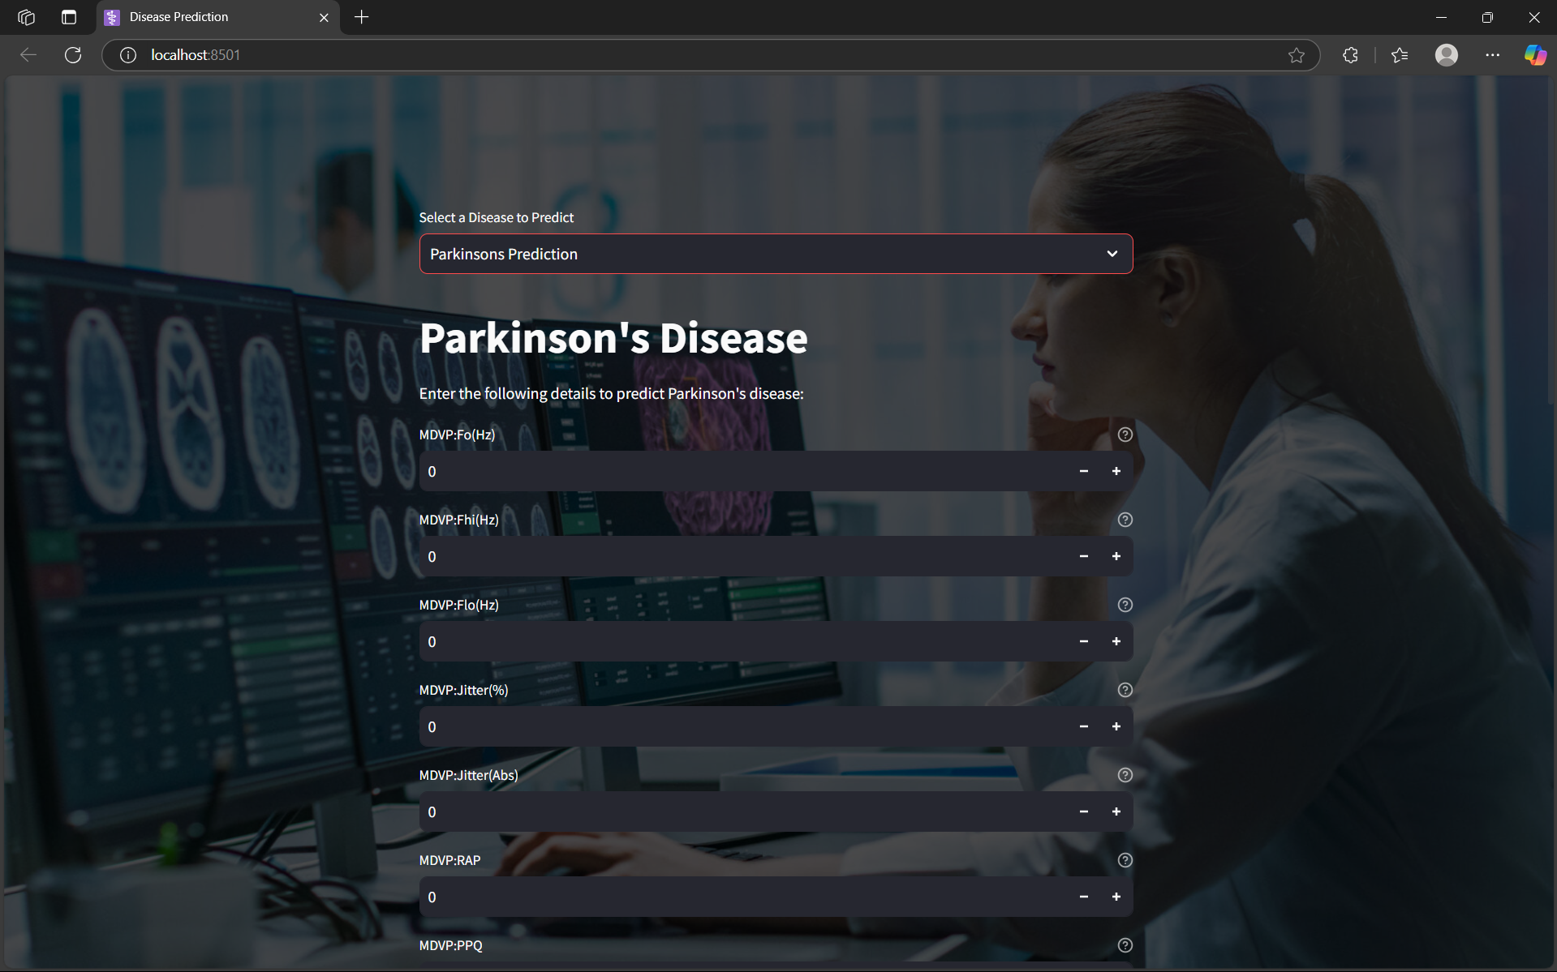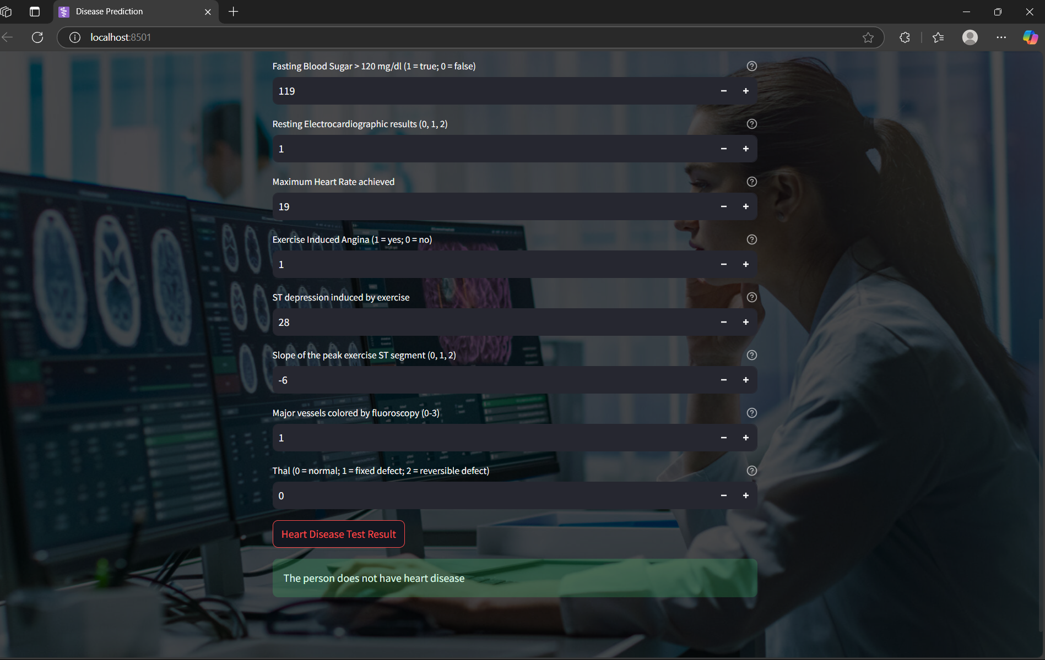

**Fig:4.1(open in web browser)**

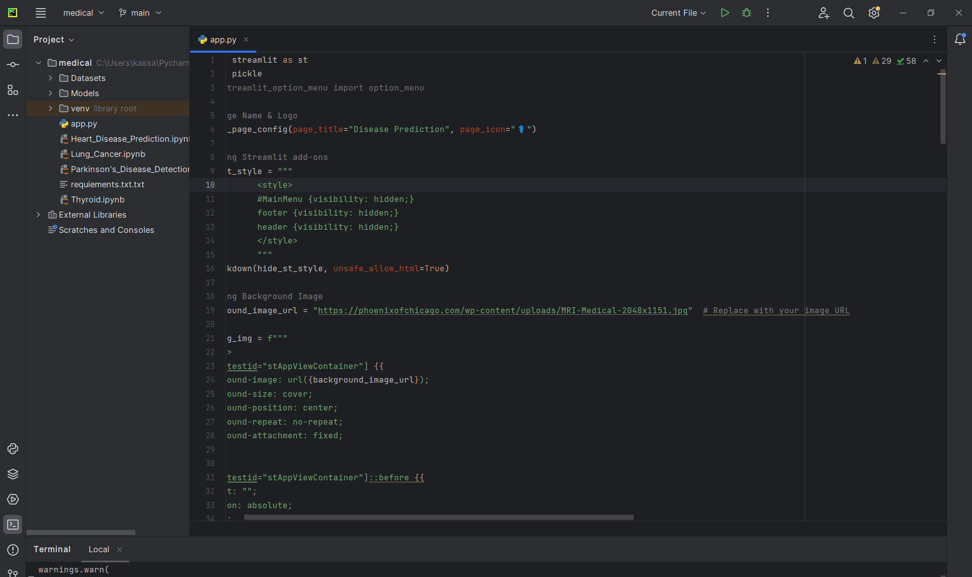

**Fig:4.2(code in code editor)**

* 1. **GitHub Link for Code:** [**kassasanathkumar/Medical-Diagnosis**](https://github.com/kassasanathkumar/Medical-Diagnosis)

**CHAPTER 5**

**Discussion and Conclusion**

**5.1 Future Work**

While the current AI-powered Medical Diagnosis System provides preliminary disease prediction, there are several areas for improvement and expansion in future iterations:

1. Expansion to More Diseases:
   * Currently, the system predicts five diseases (Diabetes, Heart Disease, Parkinson’s, Lung Cancer, and Hypothyroidism). Future versions could incorporate additional diseases such as Alzheimer’s, Chronic Kidney Disease, and Hypertension.
2. Integration of Deep Learning for Image-Based Diagnosis:
   * Incorporating Convolutional Neural Networks (CNNs) can enable medical image analysis for detecting diseases like cancer through X-ray, MRI, or CT scans.
3. Real-Time Data Integration from IoT Devices:
   * Wearable devices (e.g., smartwatches, glucose monitors) could be connected for real-time health monitoring and predictive analytics.
4. Enhancing Model Accuracy and Interpretability:
   * Using advanced techniques such as Explainable AI (XAI) to provide interpretable predictions for doctors and patients.
   * Continuously updating models with new and diverse datasets to improve accuracy across different populations.
5. Mobile Application Development:
   * Expanding the system as a mobile app for better accessibility and real-time health tracking.
6. Integration with Telemedicine Services:
   * Allowing patients to share their AI-based reports with healthcare professionals for further consultation.

**5.2 Conclusion**

This project successfully demonstrates the potential of AI in medical diagnostics, providing a user-friendly and accessible web-based tool for preliminary disease prediction. By leveraging machine learning models, the system helps users assess their health risks based on input medical parameters.

The key contributions of this project include:  
✅ Development of a multi-disease diagnostic system using AI.  
✅ Deployment of an interactive web application via Streamlit.  
✅ Implementation of multiple machine learning models to ensure accurate predictions.  
✅ Encouraging early detection and awareness of critical health conditions.

Although this tool does not replace professional medical consultation, it serves as an important decision-support system, especially for early screening. With further enhancements, such as real-time data integration and deep learning-based medical imaging, the project can be extended into a more advanced AI-driven healthcare assistant.

**REFERENCES**

1. [1] M. A. A. Muhammad and F. Madi, “Machine learning for medical diagnosis: A review of current trends and future perspectives,” *J. Healthc. Inform.*, vol. 15, no. 3, pp. 45–60, 2021.
2. [2] L. Deng and D. Yu, “Deep learning: Methods and applications,” *Found. Trends Signal Process.*, vol. 7, no. 3–4, pp. 197–387, 2014.
3. [3] A. Rajkomar, J. Dean, and I. Kohane, “Machine learning in medicine,” *N. Engl. J. Med.*, vol. 380, pp. 1347–1358, 2019.
4. [4] F. Pedregosa, G. Varoquaux, A. Gramfort, et al., “Scikit-learn: Machine learning in Python,” *J. Mach. Learn. Res.*, vol. 12, pp. 2825–2830, 2011.
5. [5] J. Han, M. Kamber, and J. Pei, *Data Mining: Concepts and Techniques*, 3rd ed. San Francisco, CA, USA: Morgan Kaufmann, 2011.
6. [6] J. Smith, “AI-driven healthcare solutions: Opportunities and challenges,” in *Proc. Int. Conf. Artif. Intell. Healthc.*, 2020, pp. 98–105.

[7] M.-H. Yang, D. J. Kriegman, and N. Ahuja, “Detecting faces in images: A survey,” *IEEE Trans. Pattern Anal. Mach. Intell.*, vol. 24, no. 1, pp. 34–58, 2002.